Campus Oaks Phase 2
350 Roseville Parkway
Roseville, CA 95747
916-750-5615
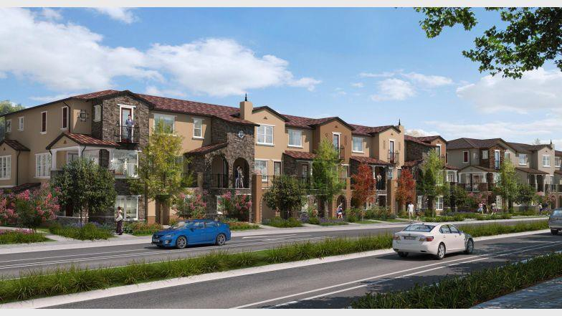
www.campusoaksapartments.com
210 Units – 45 will be reserved for very low income households
Phase 2 – Wait list will open on August 1, 2020

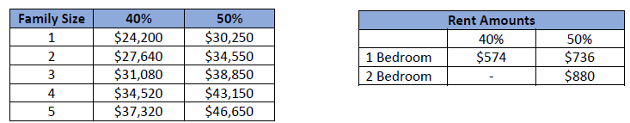

Junction Station (St. Anton)
120 Pacific Street,
Roseville, CA
www.antoncap.com
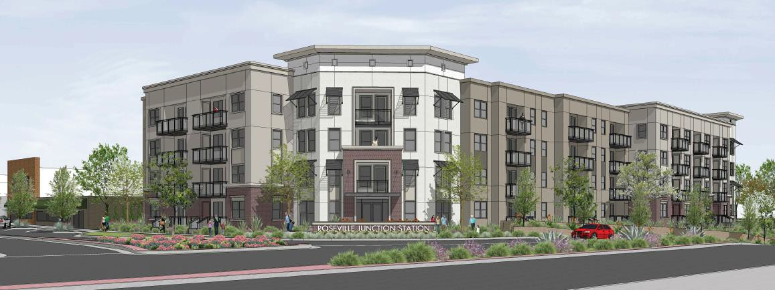

80 affordable units: Studios and 1 bedrooms affordable to very low and low income households

Rents
50% 60%
Studio - $650 $696
1 Bedroom - $780 $835
Main Street Plaza (Meta Housing)
Washington Blvd and Main Street,
Roseville, CA (Historic Old Town)
www.metahousing.com
916 561 0323
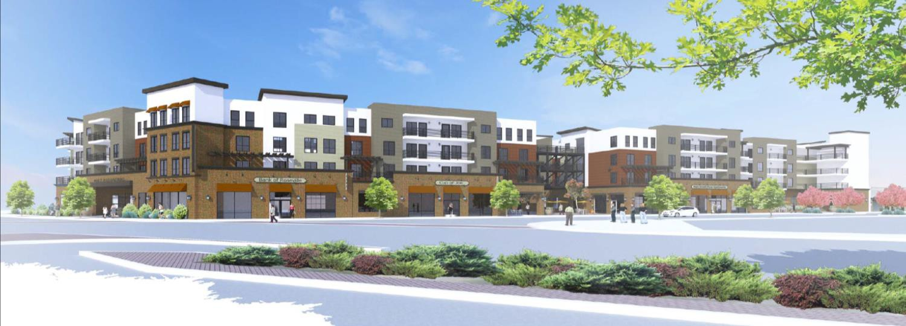

65 affordable units, including extremely low, very low, and low income households.
Estimated to be available in Fall 2020

Rents
30% 35% 40% 50% 60% Market
1 Bedroom $383 $453 - - - -
2 Bedroom $454 - $621 $788 $955 -
3 Bedroom $519 - $712 - $1,098 -
Lohse Apartments
623 Vernon Street,
Roseville, CA
Ph. (916) 472-2962
www.mercyhousing.org

Please note: Lohse Apartments currently has a waiting list of over 500 households. For this reason, the waiting list is currently closed. This website will be updated once the waiting list reopens.

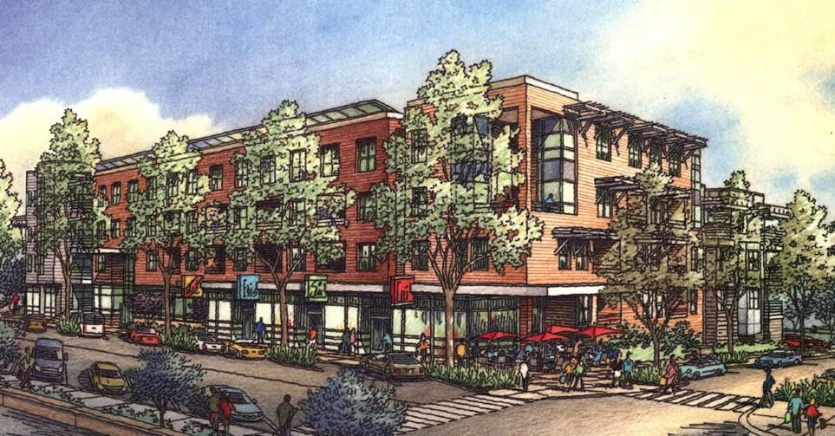

4 story complex, 100% affordable units, Housing Choice Vouchers accepted, 57 low-income units, 30% units available for very low income families.

Liberty Village (Taylor Morrison)
1001 Knox Way
Roseville, CA 95678
(916) 246-0759
www.taylormorrison.com/liberty-village

Affordable Homes Available by Liberty Village

The Anthony Plan
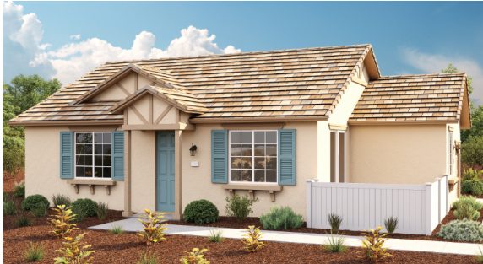

1,092 Sq Ft
3 Bedrooms & 2 Bathrooms
1 Car Garage
Pricing - $350,000
Silent Second loan of $149,370 for Low Income Buyers
Silent Second loan of $64,051 for Middle Income Buyers
Homes Available to Income-Qualified Buyers

A total of 2 low-income homes and 3 middle-income homes will be sold to income qualified households.
Download the affordable purchase application here.
ALL completed applications must be sent directly to Taylor Morrison's preferred lender at libertyaffordables@taylormorrison.com to be considered for the affordable homes being released.
NO applications should be sent to the City of Roseville Housing Division.
Prospective purchasers who are veterans or live &/or work in the City of Roseville will have preference and will be contacted by the lender's team directly.

General Affordable Housing Information:

City of Roseville – Housing Division
Roseville Housing Authority
316 Vernon Street, Suite 150
Roseville, CA 95678

www.roseville.ca.us/housing

916-774-5270
916-774-5220 [TDD]
916-746-1295 [FAX]
Email: housing@roseville.ca.us

Please email your name, address and email address to the email above if you would like to be contacted regarding future affordable rental housing opportunities.

Hours Open to the Public

Monday 9 am - 12 noon 1 pm – 3 pm
Closed for lunch 12 - 1 pm

Tuesday - Thursday 9 am – 12 noon 1 pm – 5 pm
Closed for lunch 12 - 1 pm

Friday 8 am – 12 noon

